SUBMITTED BY:

NAME | CH.V.S.ROHITH
ROLL NO | CSE25024
YEAR / SEM / SECTION | 2 / 3 / CSE-A
CREDITS | 5

SUBMITTED TO:

NAME | Dr.B.RAJ KUMAR
DEPARTMENT | SCHOOL OF COMPUTING
DESIGNATION | ASST. PROFFESOR (SI grade)

S NO: | TITLE | PAGE | REMARKS
1 | WEEK 1:  1a: Recursive countdown from n  1b: Recursive calculation of compound growth factor  1c: Recursive search for emo id in list  1d: Recursive factorial calculation  1e: Recursive fibonacci series

LAB 1

1A)

AIM: A rocket launch system displays a countdown. Use no loops. Write a Python program to display the countdown from n to 1, followed by “Launch”.

PROGRAM:

def countdown(n):
while n>0:
print(n)
n-=1
print(n)
print("Launch")

n=int(input("enter number:"))
countdown(n)

OUTPUT:

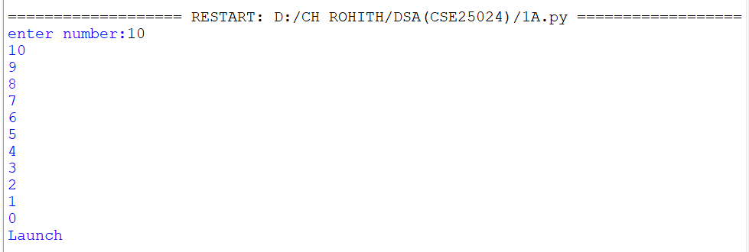

EXPLANATION:

- Defines a recursive countdown() function that prints numbers in decreasing order.
- Prints the current value of n before making the recursive call.
- When n becomes 0, the recursion stops.
- Otherwise, the function calls itself with n-1.
- Takes the starting number as input and displays the countdown.

ERROR TABLE:

S.No | Error Obtained | Rectification
1 | Countdown does not stop | Check the condition when n reaches 0
2 | Program stops for a very large number | Use a loop instead of recursion
3 | Negative numbers are printed unexpectedly | Allow only non negative starting values

1B)

AIM: Banks calculate the growth of an investment using compound interest. The formula requires calculating powers, which can be implemented recursively. Write a recursive program to calculate pⁿ (power), where p = principal growth factor and n = number of years.

PROGRAM:

def power(p, n):
if n == 0:
return 1
return p * power(p, n - 1)

p = float(input("Enter prinicipal amount: "))
n = int(input("Enter number of years: "))

print("p^n =", power(p, n))

OUTPUT:

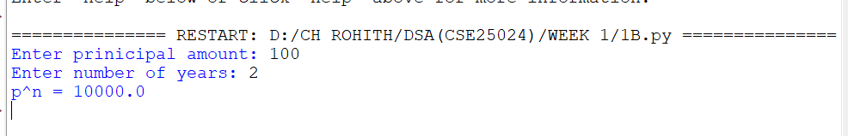

EXPLANATION:

- Defines a recursive power() function to calculate \(p^n\).
- Returns 1 when n <= 0, which is the base case.
- Otherwise, multiplies p by power(p, n-1) repeatedly.
- Takes the base (p) and exponent (n) as input.
- Calls the function and prints the calculated power.

ERROR TABLE:

S.No | Error Obtained | Rectification
1 | Incorrect result for negative exponent | Add separate handling for negative exponents
2 | Program becomes slow for large exponent | Use an efficient power calculation method
3 | Wrong result for exponent zero | Make sure the base case returns 1

1C)

AIM:An HR department stores employee IDs in a list. Develop a recursive program to search for a given employee ID. Write a recursive function to search for an employee ID in a list.

PROGRAM:

def search(A,k,n=0):
if n>=len(A):
return -1
if A[n]==k:
return n
return search(A,k,n+1)

A=[1,2,3,4,5,6,7,8]
print(A)
k=int(input("enter num to search:"))

print(search(A,k))

OUTPUT:

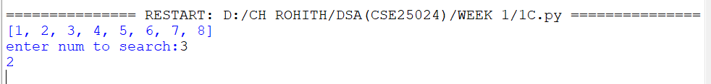

EXPLANATION:

- Defines a recursive search() function to find the target element in the list.
- Checks each element starting from index 0 using recursion.
- If the target is found, its index is returned.
- If the end of the list is reached, -1 is returned.
- Takes the target value as input and displays the search result.

ERROR TABLE:

S.No | Error Obtained | Rectification
1 | Target element is not found | Check whether the target exists in the list
2 | Recursion stops before checking all elements | Verify the index increment in the recursive call
3 | Program stops for a large list | Use an iterative search method

1D)

AIM:In a logistics company, the number of possible ways to arrange n different parcels is calculated using the factorial formula (n!). Develop a recursive program to calculate the factorial of a given number.

PROGRAM:

def factorial(n):
if n<=0:
return 1
else:
return n*factorial(n-1)

n=int(input("Enter number:"))
print(factorial(n))

OUTPUT:

EXPLANATION:

- Defines a recursive factorial() function to calculate the factorial of a number.
- Returns 1 when n <= 0, which also handles 0!.
- Otherwise, multiplies n by factorial(n-1) until reaching the base case.
- Takes a number as input from the user.
- Calls the function and prints the factorial result.

ERROR TABLE:

S.No | Error Obtained | Rectification
1 | Incorrect factorial for negative input | Restrict the input to non negative numbers
2 | Program stops for a large number | Use an iterative approach
3 | Wrong factorial result | Check the recursive multiplication and base condition

1E)

AIM:Write a recursive Python program to print the first n terms of the Fibonacci series.

PROGRAM:

def fibonacci(n):
if n<=0:
return 0
elif n==1:
return 1
else:
return fibonacci(n-1)+fibonacci(n-2)

n= int(input("Enter number of terms:"))
for i in range(n):
print(fibonacci(i))

OUTPUT:

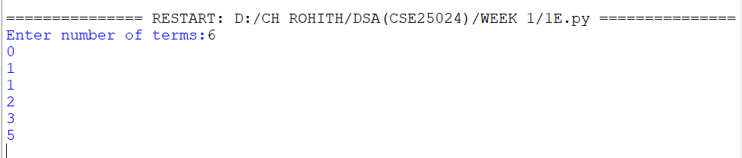

EXPLANATION:

- Defines a recursive fibonacci() function to calculate Fibonacci numbers.
- Returns 0 for n <= 0 and 1 for n == 1.
- For other values, it recursively adds the previous two Fibonacci numbers.
- Takes the number of terms from the user.
- Uses a loop to generate and print each Fibonacci term.
- The sequence starts as 0, 1, 1, 2, 3, 5, ....

ERROR TABLE:

S.No | Error Obtained | Rectification
1 | Program runs very slowly | Use an iterative or optimized approach
2 | Incorrect sequence is displayed | Check the base conditions for 0 and 1
3 | Program stops for large input | Avoid excessive recursive calls

LAB 2

2A)

AIM: Write a program to perform linear search on a given input.

PROGRAM:

def linearSearch(a,key):
for i in range(n):
if a[i]==key:
return i
return -1

n=int(input("Enter number of elements:"))
a=[]
for i in range(n):
x=int(input("Enter elements:"))
a.append(x)
key=int(input("Enter element to Find:"))
print(linearSearch(a,key))

OUTPUT:

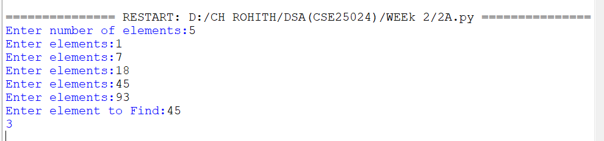

EXPLANATION:

- Takes the number of elements and stores them in a list.
- Takes the target element to be searched.
- linearSearch() checks each element one by one.
- If the target is found, its index is returned.
- If not found, -1 is returned.
- The result is displayed using print().

ERROR TABLE:

S.No | Error Obtained | Rectification
1 | Element is not found | Check whether the required element is present in the list
2 | Wrong index is displayed | Check the list indexing starting from 0
3 | Search stops unexpectedly | Verify the range used in the for loop

2B)

AIM:Write a Python program to perform binary search on the given input. Verify by taking sorted array & unsorted array as input.

PROGRAM:

def binary_search(arr, key):
low = 0
high = len(arr) - 1

while low <= high:
mid = (low + high) // 2

if arr[mid] == key:
return mid
elif arr[mid] < key:
low = mid + 1
else:
high = mid - 1

return -1

n = int(input("Enter number of elements: "))
arr = []

for i in range(n):
arr.append(int(input("Enter element: ")))

key = int(input("Enter element to search: "))

if arr == sorted(arr):
result = binary_search(arr, key)

if result != -1:
print("Element found at index", result)
else:
print("Element not found")
else:
print("Array is unsorted. Binary search cannot be performed.")

OUTPUT:

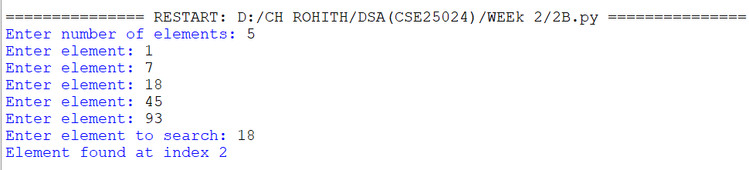

EXPLANATION:

- Takes the number of elements and stores them in a list.
- Sorts the list using a.sort() because binary search requires sorted data.
- Calculates the middle element and compares it with the target.
- If the target is smaller or larger, searches only the appropriate half.
- Returns the index if found; otherwise returns -1.
- Displays whether the element is found or not.

ERROR TABLE:

S.No | Error Obtained | Rectification
1 | Wrong element is returned | Make sure the list is sorted before searching
2 | Search gives incorrect index | Check the calculation of the middle index
3 | Element is not found | Verify the low and high boundaries

WEEK-3

3A)

Aim:Write a python program to sort an array using selection sort and take the elements as input from user

PROGRAM:

n = int(input("Enter number of elements: "))
arr = []

for i in range(n):
element = int(input("Enter element: "))
arr.append(element)

for i in range(n - 1):
min_index = i
for j in range(i + 1, n):
if arr[j] < arr[min_index]:
min_index = j

arr[i], arr[min_index] = arr[min_index], arr[i]

print("Sorted array:", arr)

OUTPUT:

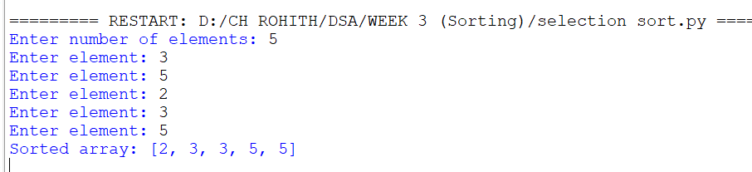

Explanation:

• Take the number of elements from the user.
• Created an empty list arr.
• Used a for loop to take each element individually.
• min_index stores the position of the smallest element.
• The inner loop searches for the smallest element in the unsorted portion.
• Swapped the smallest element with the first unsorted element.
• Repeated this until the array was sorted

Error Table:

S.No. | Errors Observed | Rectification
1) | Incorrect initialization of min_index, causing the minimum element to be identified incorrectly. | Initialize min_index = i before searching for the minimum element.
2) | Starting the inner loop from 0, causing already sorted elements to be checked again. | Start the inner loop from i + 1.
3) | Forgetting to update min_index when a smaller element is found. | Use min_index = j inside the if condition.
4) | Incorrect swapping of elements, resulting in an unsorted array. | Use arr[i], arr[min_index] = arr[min_index], arr[i].
5) | Invalid (non-numeric) input entered by the user. | Enter a valid integer for each array element.
6) | Incorrect indentation causing an IndentationError. | Maintain proper indentation inside for loops and if statements.

3B)

Aim: Write a python program to sort an array using Insertion sort and take the elements as input from user

PROGRAM:

n = int(input("Enter number of elements: "))
arr = []

for i in range(n):
element = int(input("Enter element: "))
arr.append(element)

for i in range(1, n):
key = arr[i]
j = i - 1

while j >= 0 and arr[j] > key:
arr[j + 1] = arr[j]
j = j - 1

arr[j + 1] = key

print("Sorted array:", arr)

OUTPUT:

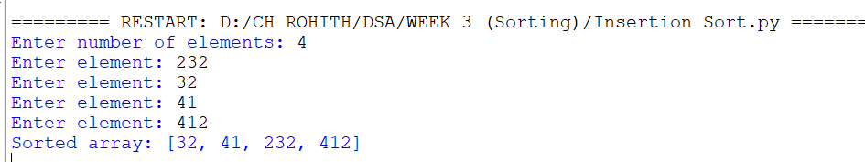

Explanation:

• Took the number of elements from the user.
• Used a loop to input every element.
• Started sorting from index 1.
• Stored the current element in key.
• Compared key with the elements before it.
• Shifted larger elements one position to the right.
• Inserted key into its correct position.
• Repeated until the array was sorted.

Error Table:

S.No. | Errors Observed | Rectification
1) | Starting the outer loop from 0, unnecessarily processing the first element. | Start the loop from 1 because the first element is already considered sorted.
2) | Forgetting to store the current element in key. | Use key = arr[i] before shifting elements.
3) | Forgetting j -= 1, causing the while loop to run indefinitely. | Decrease j by using j -= 1 after shifting an element.
4) | Placing the key at arr[j] instead of arr[j + 1]. | Insert the key using arr[j + 1] = key.
5) | Incorrect condition in the while loop. | Use j >= 0 and arr[j] > key to shift larger elements.

3C)

Aim: Write a python program to sort an array using Bubble sort and take the elements as input from user

PROGRAM:

n = int(input("Enter number of elements: "))

arr = []

for i in range(n):
element = int(input("Enter element: "))
arr.append(element)

for i in range(n - 1):
for j in range(n - 1 - i):
if arr[j] > arr[j + 1]:
# Swap
arr[j], arr[j + 1] = arr[j + 1], arr[j]

print("Sorted array:", arr)

OUTPUT:

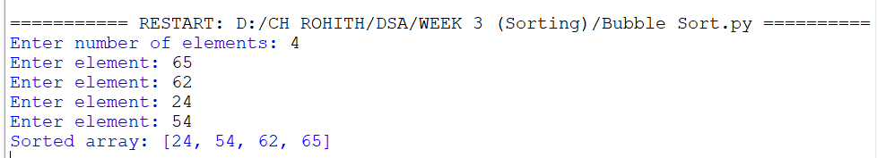

Explanation:

• Took the number of elements.
• Input each element using a loop.
• Compared two adjacent elements.
• If the left element was greater, we swapped them.
• After every pass, the largest remaining element moved to the end.
• Reduced the comparison range after every pass.
• Repeated until the array became sorted.

Error Table:

S.No. | Errors Observed | Rectification
1) | Comparing non-adjacent elements instead of neighboring elements. | Compare arr[j] with arr[j + 1].
2) | Using an incorrect inner loop range. | Use range(n - 1 - i) so that already sorted elements are not checked
3) | Forgetting to swap elements when they are in the wrong order. | Use arr[j], arr[j + 1] = arr[j + 1], arr[j].
4) | Using < instead of > for ascending order. | Use if arr[j] > arr[j + 1] for ascending sorting.
5) | Using an incorrect outer loop range. | Use range(n - 1) to perform the required passes.
6) | Entering non-numeric values as array elements. | Enter valid integer values using int(input()).

WEEK-4

4A)

Aim: Write a python programme to implement a single linked list which could perform the below operations ,by taking an input from the user.
1)create a linked list
2)Insert at beginning
3)Insert at end
4)insert at index
5)Delete by value
6)Delete First Node
7)Delete Last Node
8)Count number of nodes
9)Display/Traverse
10)Exit

PROGRAM:

# Singly Linked List Implementation

class Node:
def __init__(self, data):
self.data = data
self.next = None

class SinglyLinkedList:
def __init__(self):
self.head = None

# 1. Create Linked List
def create(self):
n = int(input("Enter number of nodes: "))

self.head = None
temp = None

for i in range(n):
data = int(input(f"Enter data for node {i + 1}: "))
new_node = Node(data)

if self.head is None:
self.head = new_node
temp = new_node
else:
temp.next = new_node
temp = new_node

print("Linked list created successfully.")

# 2. Insert at Beginning
def insert_beginning(self):
data = int(input("Enter value: "))
new_node = Node(data)

new_node.next = self.head
self.head = new_node

print("Node inserted at beginning.")

# 3. Insert at End
def insert_end(self):
data = int(input("Enter value: "))
new_node = Node(data)

if self.head is None:
self.head = new_node
print("Node inserted at end.")
return

temp = self.head

while temp.next is not None:
temp = temp.next

temp.next = new_node

print("Node inserted at end.")

# 4. Insert at Index
def insert_at_index(self):
index = int(input("Enter index: "))
data = int(input("Enter value: "))

if index < 0:
print("Invalid index.")
return

# Insert at beginning
if index == 0:
new_node = Node(data)
new_node.next = self.head
self.head = new_node
print("Node inserted.")
return

temp = self.head

for i in range(index - 1):
if temp is None:
print("Invalid index.")
return
temp = temp.next

if temp is None:
print("Invalid index.")
return

new_node = Node(data)
new_node.next = temp.next
temp.next = new_node

print("Node inserted at index", index)

# 5. Delete by Value
def delete_by_value(self):
value = int(input("Enter value to delete: "))

if self.head is None:
print("Linked list is empty.")
return

# If first node contains the value
if self.head.data == value:
self.head = self.head.next
print("Node deleted.")
return

temp = self.head

while temp.next is not None:
if temp.next.data == value:
temp.next = temp.next.next
print("Node deleted.")
return

temp = temp.next

print("Value not found.")

# 6. Delete First Node
def delete_first(self):
if self.head is None:
print("Linked list is empty.")
return

self.head = self.head.next
print("First node deleted.")

# 7. Delete Last Node
def delete_last(self):
if self.head is None:
print("Linked list is empty.")
return

# Only one node
if self.head.next is None:
self.head = None
print("Last node deleted.")
return

temp = self.head

while temp.next.next is not None:
temp = temp.next

temp.next = None

print("Last node deleted.")

# 8. Count Number of Nodes
def count_nodes(self):
count = 0
temp = self.head

while temp is not None:
count += 1
temp = temp.next

print("Number of nodes:", count)

# 9. Display / Traverse
def display(self):
if self.head is None:
print("Linked list is empty.")
return

temp = self.head

print("Linked List:", end=" ")

while temp is not None:
print(temp.data, end=" -> ")
temp = temp.next

print("None")

# Main Program

linked_list = SinglyLinkedList()

while True:
print("\n========== SINGLY LINKED LIST ==========")
print("1. Create Linked List")
print("2. Insert at Beginning")
print("3. Insert at End")
print("4. Insert at Index")
print("5. Delete by Value")
print("6. Delete First Node")
print("7. Delete Last Node")
print("8. Count Number of Nodes")
print("9. Display / Traverse")
print("10. Exit")

choice = int(input("Enter your choice: "))

if choice == 1:
linked_list.create()

elif choice == 2:
linked_list.insert_beginning()

elif choice == 3:
linked_list.insert_end()

elif choice == 4:
linked_list.insert_at_index()

elif choice == 5:
linked_list.delete_by_value()

elif choice == 6:
linked_list.delete_first()

elif choice == 7:
linked_list.delete_last()

elif choice == 8:
linked_list.count_nodes()

elif choice == 9:
linked_list.display()

elif choice == 10:
print("Program exited.")
break

else:
print("Invalid choice. Please try again.")

OUTPUT:

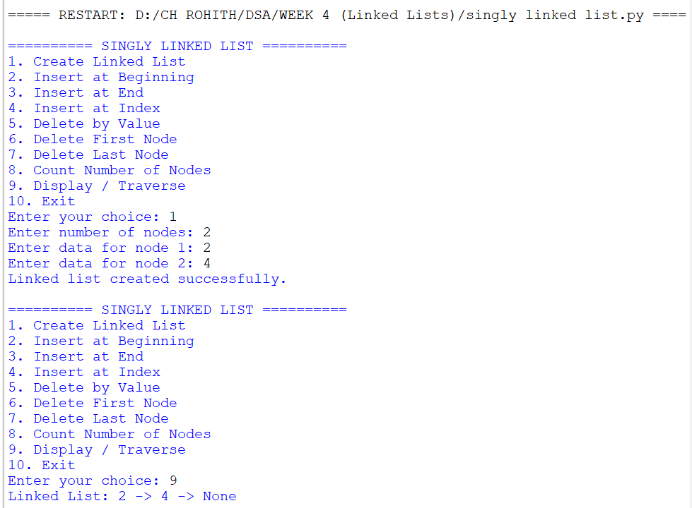

Explanation:

- Defines Node and SLL classes to create and manage a singly linked list.
- The create function creates nodes and connects them using the next pointer.
- Provides operations to insert nodes at the beginning, end, and a specific index.
- Provides operations to delete a node by value, from the beginning, and from the end.
- The count and display functions show the number of nodes and the contents of the list.
- A menu driven loop allows the user to select and perform different linked list operations.

Error Table:

S.No. | Errors Observed | Rectification
1) | IndentationError in class or function definitions | Maintain proper indentation inside classes and functions
2) | AttributeError while accessing next | Check that the node is created correctly before accessing next
3) | Index out of range during insertion | Enter an index within the valid linked list range

4B)

Aim: Write a python program to implement a Double linked list which could perform the below operations ,by taking an input from the user.
1)Insert at beginning
2)Insert at end
3)insert at index
4)Delete by value
5)Delete First Node
6)Delete Last Node
7)Display the Forward Nodes
8)Display the Backward Nodes
9)Exit

PROGRAM:

# Doubly Linked List Implementation

class Node:
def __init__(self, data):
self.data = data
self.prev = None
self.next = None

class DoublyLinkedList:

def __init__(self):
self.head = None

# 1. Insert at Beginning
def insert_beginning(self):
data = int(input("Enter value: "))
new_node = Node(data)

if self.head is None:
self.head = new_node
else:
new_node.next = self.head
self.head.prev = new_node
self.head = new_node

print("Node inserted at beginning.")

# 2. Insert at End
def insert_end(self):
data = int(input("Enter value: "))
new_node = Node(data)

if self.head is None:
self.head = new_node
print("Node inserted at end.")
return
temp = self.head

while temp.next is not None:
temp = temp.next

temp.next = new_node
new_node.prev = temp

print("Node inserted at end.")

# 3. Insert at Index
def insert_at_index(self):
index = int(input("Enter index: "))
data = int(input("Enter value: "))

if index < 0:
print("Invalid index.")
return

# Insert at beginning
if index == 0:
new_node = Node(data)

new_node.next = self.head

if self.head is not None:
self.head.prev = new_node

self.head = new_node

print("Node inserted.")
return

temp = self.head

# Move to node before the required index
for i in range(index - 1):
if temp is None:
print("Invalid index.")
return
temp = temp.next

if temp is None:
print("Invalid index.")
return

new_node = Node(data)

new_node.next = temp.next
new_node.prev = temp

if temp.next is not None:
temp.next.prev = new_node

temp.next = new_node

print("Node inserted at index", index)

# 4. Delete by Value
def delete_by_value(self):
value = int(input("Enter value to delete: "))

if self.head is None:
print("Linked list is empty.")
return

temp = self.head

while temp is not None:

if temp.data == value:

# If deleting first node
if temp.prev is None:
self.head = temp.next

if self.head is not None:
self.head.prev = None

# If deleting any other node
else:
temp.prev.next = temp.next

if temp.next is not None:
temp.next.prev = temp.prev

print("Node deleted.")
return

temp = temp.next

print("Value not found.")

# 5. Delete First Node
def delete_first(self):
if self.head is None:
print("Linked list is empty.")
return

self.head = self.head.next

if self.head is not None:
self.head.prev = None

print("First node deleted.")

# 6. Delete Last Node
def delete_last(self):
if self.head is None:
print("Linked list is empty.")
return

temp = self.head

# Only one node
if temp.next is None:
self.head = None
print("Last node deleted.")
return

while temp.next is not None:
temp = temp.next

temp.prev.next = None

print("Last node deleted.")

# 7. Display Forward Nodes
def display_forward(self):
if self.head is None:
print("Linked list is empty.")
return

temp = self.head

print("Forward: ", end="")

while temp is not None:
print(temp.data, end=" <-> ")
temp = temp.next

print("None")

# 8. Display Backward Nodes
def display_backward(self):
if self.head is None:
print("Linked list is empty.")
return

temp = self.head

# Move to last node
while temp.next is not None:
temp = temp.next

print("Backward: ", end="")

while temp is not None:
print(temp.data, end=" <-> ")
temp = temp.prev

print("None")

# Main Program

dll = DoublyLinkedList()

while True:
print("\n========== DOUBLY LINKED LIST ==========")
print("1. Insert at Beginning")
print("2. Insert at End")
print("3. Insert at Index")
print("4. Delete by Value")
print("5. Delete First Node")
print("6. Delete Last Node")
print("7. Display Forward Nodes")
print("8. Display Backward Nodes")
print("9. Exit")

choice = int(input("Enter your choice: "))

if choice == 1:
dll.insert_beginning()

elif choice == 2:
dll.insert_end()

elif choice == 3:
dll.insert_at_index()

elif choice == 4:
dll.delete_by_value()

elif choice == 5:
dll.delete_first()

elif choice == 6:
dll.delete_last()

elif choice == 7:
dll.display_forward()

elif choice == 8:
dll.display_backward()

elif choice == 9:
print("Program exited.")
break

else:
print("Invalid choice. Please try again.")

OUTPUT:

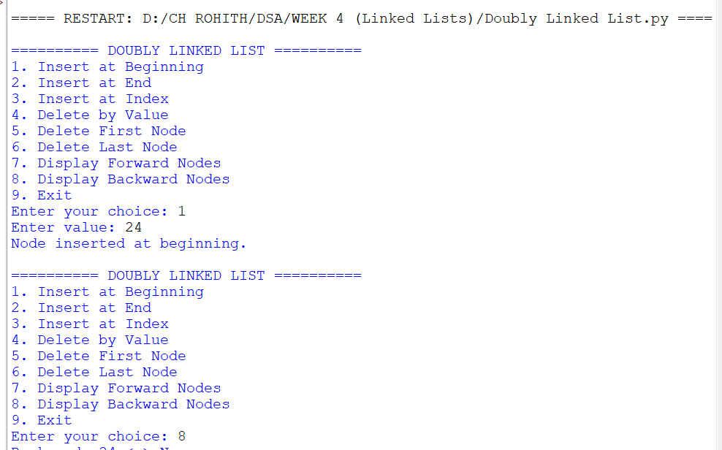

Explanation:

- Defines a Node class with data, previous link and next link for a doubly linked list.
- Provides functions to insert nodes at the beginning, end and a specific index.
- Provides functions to delete nodes from the beginning, end and a specific index.
- Maintains both prev and next links while inserting and deleting nodes.
- The display functions show the list in forward and backward directions.
- A menu allows the user to perform different doubly linked list operations.

Error Table:

S.No. | Errors Observed | Rectification
1) | Invalid Index during insertion | Enter an index within the valid list range
2) | Links are not updated correctly after deletion | Update both prev and next links properly
3) | Backward display gives incorrect order | Traverse to the last node before moving backward

4C)

Aim:

Write a python program to implement a Circular linked list which could perform the below operations ,by taking an input from the user.
1)create a linked list
2)Insert at beginning
3)Insert at end
4)insert at index
5)Delete by value
6)Delete First Node
7)Delete Last Node
8)Count number of nodes
9)Display
a)Head to Tail
b)Tail to Head
10)Exit

PROGRAM:

# Circular Linked List Implementation

class Node:
def __init__(self, data):
self.data = data
self.next = None

class CircularLinkedList:

def __init__(self):
self.head = None

# 1. Create Linked List
def create(self):
n = int(input("Enter number of nodes: "))

self.head = None
tail = None

for i in range(n):
data = int(input(f"Enter data for node {i + 1}: "))
new_node = Node(data)

if self.head is None:
self.head = new_node
tail = new_node
new_node.next = self.head
else:
tail.next = new_node
tail = new_node
tail.next = self.head

print("Circular linked list created successfully.")

# 2. Insert at Beginning
def insert_beginning(self):
data = int(input("Enter value: "))
new_node = Node(data)

if self.head is None:
self.head = new_node
new_node.next = self.head
print("Node inserted at beginning.")
return

tail = self.head

while tail.next != self.head:
tail = tail.next

new_node.next = self.head
self.head = new_node
tail.next = self.head

print("Node inserted at beginning.")

# 3. Insert at End
def insert_end(self):
data = int(input("Enter value: "))
new_node = Node(data)

if self.head is None:
self.head = new_node
new_node.next = self.head
print("Node inserted at end.")
return

tail = self.head

while tail.next != self.head:
tail = tail.next

tail.next = new_node
new_node.next = self.head

print("Node inserted at end.")

# 4. Insert at Index
def insert_at_index(self):
index = int(input("Enter index: "))
data = int(input("Enter value: "))

if index < 0:
print("Invalid index.")
return

# Insert at beginning
if index == 0:
new_node = Node(data)

if self.head is None:
self.head = new_node
new_node.next = self.head
else:
tail = self.head

while tail.next != self.head:
tail = tail.next

new_node.next = self.head
self.head = new_node
tail.next = self.head

print("Node inserted.")
return

if self.head is None:
print("Invalid index.")
return

temp = self.head
current_index = 0

# Find node before the required index
while current_index < index - 1:
temp = temp.next
current_index += 1

if temp == self.head:
print("Invalid index.")
return

new_node = Node(data)

new_node.next = temp.next
temp.next = new_node

print("Node inserted at index", index)

# 5. Delete by Value
def delete_by_value(self):
value = int(input("Enter value to delete: "))

if self.head is None:
print("Linked list is empty.")
return

# If only one node
if self.head.next == self.head:
if self.head.data == value:
self.head = None
print("Node deleted.")
else:
print("Value not found.")
return

# If head contains the value
if self.head.data == value:
tail = self.head

while tail.next != self.head:
tail = tail.next

self.head = self.head.next
tail.next = self.head

print("Node deleted.")
return

# Search for the value
temp = self.head

while temp.next != self.head:
if temp.next.data == value:
temp.next = temp.next.next
print("Node deleted.")
return

temp = temp.next

print("Value not found.")

# 6. Delete First Node
def delete_first(self):
if self.head is None:
print("Linked list is empty.")
return

# Only one node
if self.head.next == self.head:
self.head = None
print("First node deleted.")
return

tail = self.head

while tail.next != self.head:
tail = tail.next

self.head = self.head.next
tail.next = self.head

print("First node deleted.")

# 7. Delete Last Node
def delete_last(self):
if self.head is None:
print("Linked list is empty.")
return

# Only one node
if self.head.next == self.head:
self.head = None
print("Last node deleted.")
return

temp = self.head

# Find second-last node
while temp.next.next != self.head:
temp = temp.next

temp.next = self.head

print("Last node deleted.")

# 8. Count Number of Nodes
def count_nodes(self):
if self.head is None:
print("Number of nodes: 0")
return

count = 0
temp = self.head

while True:
count += 1
temp = temp.next

if temp == self.head:
break

print("Number of nodes:", count)

# 9(a). Display Head to Tail
def display_head_to_tail(self):
if self.head is None:
print("Linked list is empty.")
return

temp = self.head

print("Head to Tail:", end=" ")

while True:
print(temp.data, end=" -> ")
temp = temp.next

if temp == self.head:
break

print("(Head)")

# 9(b). Display Tail to Head
def display_tail_to_head(self):
if self.head is None:
print("Linked list is empty.")
return

# Store nodes in a list
nodes = []
temp = self.head

while True:
nodes.append(temp.data)
temp = temp.next

if temp == self.head:
break

print("Tail to Head:", end=" ")

for i in range(len(nodes) - 1, -1, -1):
print(nodes[i], end=" -> ")

print("(Head)")

# Main Program

cll = CircularLinkedList()

while True:

print("\n========== CIRCULAR LINKED LIST ==========")
print("1. Create Linked List")
print("2. Insert at Beginning")
print("3. Insert at End")
print("4. Insert at Index")
print("5. Delete by Value")
print("6. Delete First Node")
print("7. Delete Last Node")
print("8. Count Number of Nodes")
print("9. Display")
print(" a. Head to Tail")
print(" b. Tail to Head")
print("10. Exit")

choice = int(input("Enter your choice: "))

if choice == 1:
cll.create()

elif choice == 2:
cll.insert_beginning()

elif choice == 3:
cll.insert_end()

elif choice == 4:
cll.insert_at_index()

elif choice == 5:
cll.delete_by_value()

elif choice == 6:
cll.delete_first()

elif choice == 7:
cll.delete_last()

elif choice == 8:
cll.count_nodes()

elif choice == 9:
print("\na. Head to Tail")
print("b. Tail to Head")

sub_choice = input("Enter your choice: ")

if sub_choice == 'a':
cll.display_head_to_tail()

elif sub_choice == 'b':
cll.display_tail_to_head()

else:
print("Invalid choice.")

elif choice == 10:
print("Program exited.")
break

else:
print("Invalid choice. Please try again.")

OUTPUT:

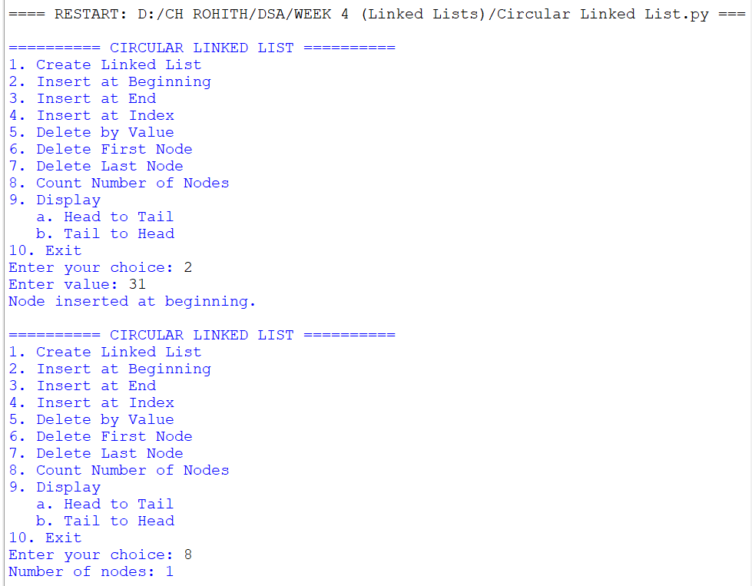

Explanation:

- Defines Node and CircularLinkedList classes where the last node points back to the head.
- Provides functions to create and insert nodes at the beginning, end and a specific index.
- Provides functions to delete nodes by value, from the beginning and from the end.
- Count and display functions traverse the list until they reach the head again.
- Additional functions display the head and tail and traverse the list from tail to head.
- A menu allows the user to perform different circular linked list operations.

Error Table:

S.No. | Errors Observed | Rectification
1) | Infinite loop while traversing the list | Stop traversal when the current node reaches the head
2) | Incorrect head after deletion | Update the head and last node link correctly
3) | Index out of range during insertion | Enter an index within the valid list range

